WEST YORKSHIRE FIRE & RESCUE SERVICE

JOB DESCRIPTION

POST TITLE: | Firefighter – Technical Rescue and USAR Technician
RESPONSIBLE TO: | Crew Commander
PURPOSE OF POST: | To deliver the Service’s aim, priorities/ objectives and to promote the safety and well-being of individuals/ communities by preventing, protecting and responding to incidents/ emergencies.

MAIN DUTIES AND RESPONSIBILITIES OF THE ROLE

- Inform and educate the community to improve awareness of safety matters.

- Take responsibility for effective performance.

- Save and preserve endangered life.

- Resolve operational incidents.

- Resolve operational incidents as part of the Technical Rescue Team (TRT) capability.

- Undertake any necessary training required to develop skills associated with the requirements of the specialist role for TRT and Urban Search and Rescue (USAR).

- Provide On Call response to USAR incidents.

- Protect the environment from the effects of hazardous materials.

- Support the effectiveness of operational response.

- Support the development of colleagues in the workplace.

- Contribute to safety solutions to minimise risks to your community.

- Drive, maneuver, and redeploy fire service vehicles.

- Ensure full compliance with the General Data Protection Regulation and Data Protection Act 2018, and to ensure data security is maintained.

- Undertake any other duties commensurate within the post as directed by line management.

ORGANISATIONAL WIDE RESPONSBILITIES:

- Adherence to the Core Code which sets out five ethical principles, based on the Seven Principles of Public Life.
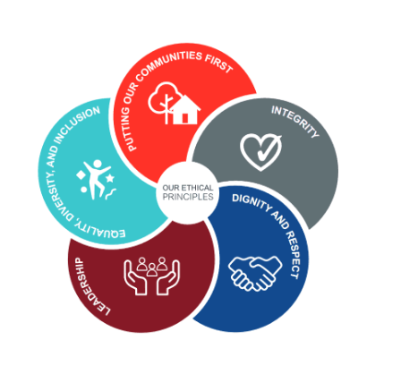

- To Implement and promote the Authority’s:
- Health and Safety policies.
- Equality and Diversity policies.
- Information Security Management System policies.
- Safeguarding policies.
- Business continuity policy and contingency arrangements.
- Policies related to General Data Protection Regulation and Data Protection Act 2018.
- Commitment to maintaining our Customer Service expectations.

SKILLS AND EXPERIENCE REQUIREMENTS FOR THIS ROLE.

In the supporting statement section of the application form give clear, concise examples of how you meet all of the Essential person specification criteria (i.e. items you must be able to do from day one to be able to do the job), identified as ‘Application’ in order to be shortlisted for this vacancy. If a large number of applications are received, only those who also meet the Desirable criteria, identified as ‘Application,’ will be shortlisted, i.e., criteria you need to do the job, but which could be learnt during training.

Please list or number the competency criteria below against which you are providing evidence/examples in order to structure your supporting statement in a well organised way.

There may be some criteria that are identified through ‘Selection Process’ only. You will only be assessed on these criteria during the selection process and not from your application form, this may involve tests, presentations, interview etc.

 | Experience. | Essential/ Desirable. | Where identified.
 | Experience of operating in a technical rescue environment. | Desirable | Application & Selection Process
 | Experience of operating within a multi- agency environment. | Desirable | Application & Selection Process
 | Knowledge and understanding of the role of TRT and USAR. | Desirable | Application & Selection Process

 | Education and Training. | Essential/ Desirable | Where identified.
 | Evidence of continuous commitment to develop self and others. | Essential | Application & Selection Process
 | Achieve and maintain the required fitness levels to meet operational requirements. | Essential | Application & Selection Process

 | Special Knowledge and Skills. | Essential/ Desirable. | Where identified.
 | Communicate effectively both orally and written to a range of different audiences. | Essential | Application & Selection Process
 | Work under supervision and take direction where appropriate. Also being able to work independently/use own initiative. | Essential | Application & Selection Process
 | Establish and maintain effective working relationships with colleagues and other agencies to contribute to a positive working environment. | Essential | Application & Selection Process
 | Understand and respect diversity to adopt a fair and ethical approach to others, and challenge inappropriate behaviours. | Essential | Application & Selection Process
 | Maintain an active situational awareness and promote a safe and effective working environment. | Essential | Application & Selection Process
 | Commitment to providing a high-quality standard of service within the Authority and to the community. | Essential | Application & Selection Process
 | Maintain a confident and resilient attitude in highly challenging situations and be able to use personal judgement to contribute towards successful outcomes. | Essential | Application & Selection Process
 | Open to change with a desire to actively seek and support it. | Essential | Application & Selection Process
 | Demonstrate a conscientious and proactive approach to achieve excellent standards, whilst maintaining the trust and confidence in the organization. | Essential | Application & Selection Process
 | Solve problems by understanding, recalling, applying, and adapting relevant information in an organised, safe, and systematic way. | Essential | Application & Selection Process
 | Hold and maintain a current full valid driving licence. | Essential | Application & Selection Process
 | Knowledge and understanding of National Coordination and Advisory Framework (NCAF). | Desirable | Application & Selection Process
 | Knowledge and understanding of Technical Rescue / USAR technical guidance | Desirable | Application & Selection Process
 | Hold and maintain a current full valid LGV driving licence. | Desirable | Application & Selection Process

 | Work related circumstances | Essential/ Desirable. | Where identified.
 | Be able to fulfil the requirements of the authority’s shift systems and prepared to work throughout West Yorkshire and the UK as required, to meet the demands of the service. | Essential | Application & Selection Process
 | Must reside within a 45-minute travel time of BD11 2DY to enable you to fulfil the On-Call element of your duties (Utilising AA route planner). | Essential | Application & Selection Process

Special Conditions of Firefighter Technical Rescue and USAR recruitment
The successful completion of an Enhanced Disclosure and Barring Service check (DBS) is required for this post.

Job Description: Last updated: 23rd January 2025

